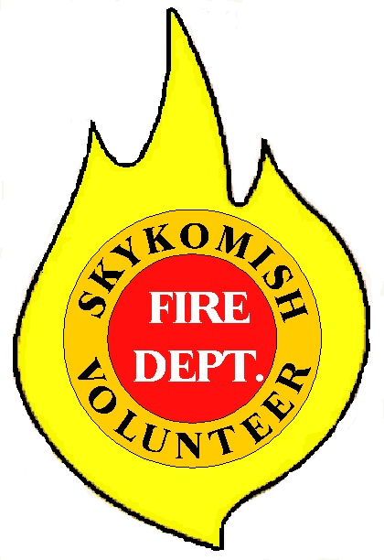King County Fire Protection District No. 50
107 West Cascade Highway
PO Box 311
Skykomish, W A 98288
360 677-2686

BOARD OF COMMISSIONERS
REGULAR MEETING AGENDA
03/07/2024-1600 HOURS
Held at District Headquarters
Located at 107 West Cascade Highway, Skykomish

OPENING-CHAIRMAN

APPROVAL OF MINUTES OF PREVIOUS MEETING – 02/08/2024

SECRETARIES REPORT:

Correspondence:

Financial Report:

Approval and signing of blanket vouchers

CHIEF’S REPORT:

EXECUTIVE SESSION:

OLD BUSINESS:

NEW BUSINESS:

ADJOURNMENT:

